Governance and Compliance

Azure Regions
Regions and Availability Zones in Azure | Microsoft Docs
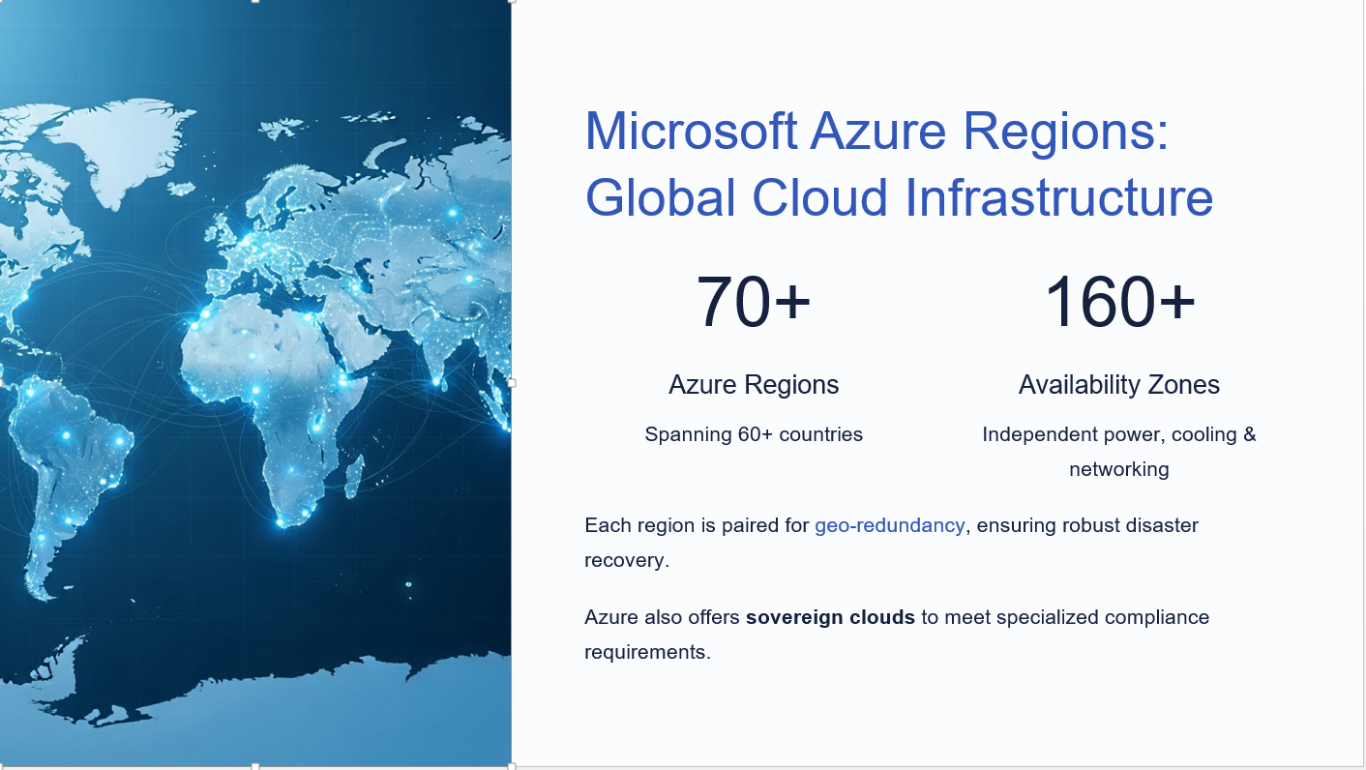

What Is An Azure Subscription?
As the name suggests, a subscription refers to the logical entity that provides entitlement to deploy and consume Azure resources. Imagine Azure subscriptions to be like a pre-paid SIM activation with or without credit. Depending on the type, these can be free subscriptions, Pay-As-You-Go (Post-Paid) subscription or a pre-paid credit carrying subscription.
A subscription fuels the Azure resources in a customer tenant. Everything will suspend or halt if the subscription carries zero credit unless the subscription is a post-paid pay-as-you-go subscription.

Cost Management:
Cost management is the process by which one plans and manages the budget of a business or project. In the case of a project, it helps the project manager estimate what the project will cost and set in place controls by which they can reduce the chance of the project going over budget.

Resource Tags:
Use tags to organize your Azure resources and management hierarchy. Tags are one of the most useful features in Azure which allows for the grouping of resources using tags for various purposes including billing, charge-back, identifying resources of an application, grouping resources by department, identifying production/test/staging environments, etc.

What is an Azure Policy?

- Policy definition is the conditions which you want controlled. ...
- Policy assignment is the scope of what the policy definition can take effect around. ...
- Policy parameters are used by reducing the number of policy definitions you must create. ...
Azure Policy helps to enforce organizational standards and to assess compliance at-scale. Through its compliance dashboard, it provides an aggregated view to evaluate the overall state of the environment, with the ability to drill down to the per-resource, per-policy granularity. It also helps to bring your resources to compliance through bulk remediation for existing resources and automatic remediation for new resources.
Common use cases for Azure Policy include implementing governance for resource consistency, regulatory compliance, security, cost, and management. Policy definitions for these common use cases are already available in your Azure environment as built-ins to help you get started.
All Azure Policy data and objects are encrypted at rest. For more information, see Azure data encryption at rest.

Overview
Azure Policy evaluates resources in Azure by comparing the properties of those resources to business rules. These business rules, described in JSON format, are known as policy definitions. To simplify management, several business rules can be grouped together to form a policy initiative (sometimes called a policySet). Once your business rules have been formed, the policy definition or initiative is assigned to any scope of resources that Azure supports, such as management groups, subscriptions, resource groups, or individual resources. The assignment applies to all resources within the Resource Manager scope of that assignment. Subscopes can be excluded, if necessary. For more information, see Scope in Azure Policy.
Azure Policy uses a JSON format to form the logic the evaluation uses to determine whether a resource is compliant or not. Definitions include metadata and the policy rule. The defined rule can use functions, parameters, logical operators, conditions, and property aliases to match exactly the scenario you want. The policy rule determines which resources in the scope of the assignment get evaluated.

Understand evaluation outcomes
Resources are evaluated at specific times during the resource lifecycle, the policy assignment lifecycle, and for regular ongoing compliance evaluation. The following are the times or events that cause a resource to be evaluated:
- A resource is created, updated, or deleted in a scope with a policy assignment.
- A policy or initiative is newly assigned to a scope.
- A policy or initiative already assigned to a scope is updated.
- During the standard compliance evaluation cycle, which occurs once every 24 hours.
For detailed information about when and how policy evaluation happens, see Evaluation triggers.

Control the response to an evaluation
Business rules for handling non-compliant resources vary widely between organizations. Examples of how an organization wants the platform to respond to a non-compliant resource include:
- Deny the resource change
- Log the change to the resource
- Alter the resource before the change
- Alter the resource after the change
- Deploy related compliant resources
Azure Policy makes each of these business responses possible through the application of effects. Effects are set in the policy rule portion of the policy definition.

Remediate non-compliant resources
While these effects primarily affect a resource when the resource is created or updated, Azure Policy also supports dealing with existing non-compliant resources without needing to alter that resource. For more information about making existing resources compliant, see remediating resources.

Azure Policy and Azure RBAC
There are a few key differences between Azure Policy and Azure role-based access control (Azure RBAC). Azure Policy evaluates state by examining properties on resources that are represented in Resource Manager and properties of some Resource Providers. Azure Policy doesn't restrict actions (also called operations). Azure Policy ensures that resource state is compliant to your business rules without concern for who made the change or who has permission to make a change.
Azure RBAC focuses on managing user actions at different scopes. If control of an action is required, then Azure RBAC is the correct tool to use. Even if an individual has access to perform an action, if the result is a non-compliant resource, Azure Policy still blocks the create or update.
The combination of Azure RBAC and Azure Policy provides full scope control in Azure.

Management Groups:
Management groups are containers that help you manage access, policy, and compliance across multiple subscriptions. Create these containers to build an effective and efficient hierarchy that can be used with Azure Policy and Azure Role Based Access Controls.

Hierarchy of management groups and subscriptions
You can build a flexible structure of management groups and subscriptions to organize your resources into a hierarchy for unified policy and access management. The following diagram shows an example of creating a hierarchy for governance using management groups.
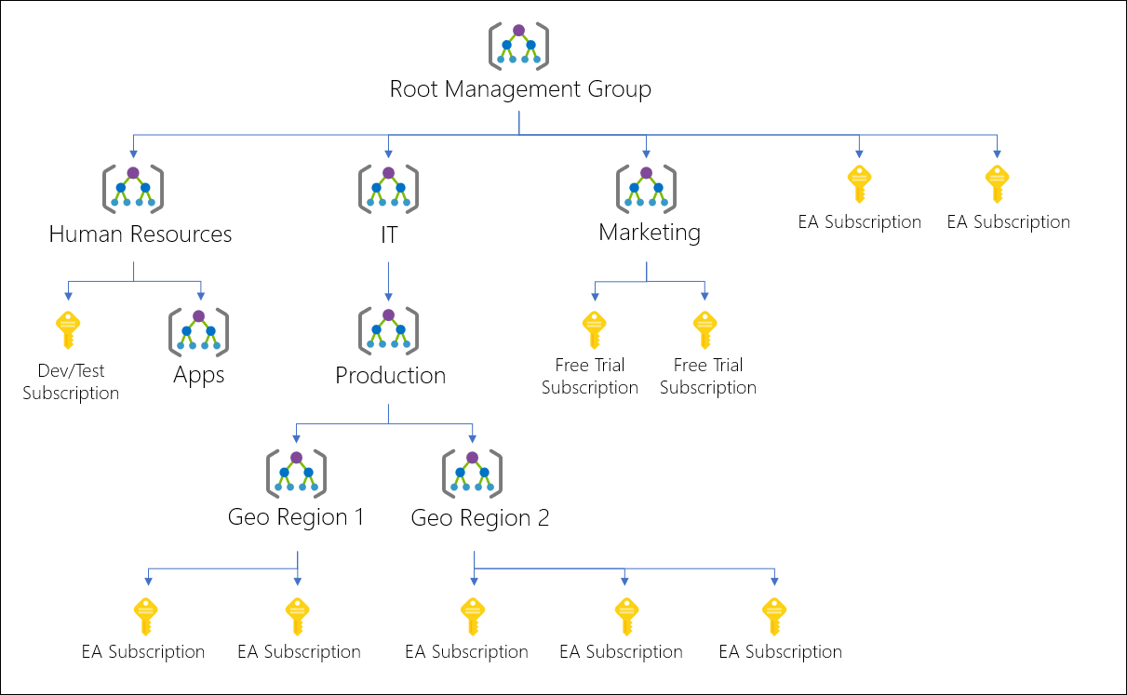
Diagram of a root management group holding both management groups and subscriptions. Some child management groups hold management groups, some hold subscriptions, and some hold both. One of the examples in the sample hierarchy is four levels of management groups with the child level being all subscriptions.
You can create a hierarchy that applies a policy, for example, which limits VM locations to the US West Region in the group called "Production". This policy will inherit onto all the Enterprise Agreement (EA) subscriptions that are descendants of that management group and will apply to all VMs under those subscriptions. This security policy cannot be altered by the resource or subscription owner allowing for improved governance.
Another scenario where you would use management groups is to provide user access to multiple subscriptions. By moving multiple subscriptions under that management group, you can create one Azure role assignment on the management group, which will inherit that access to all the subscriptions. One assignment on the management group can enable users to have access to everything they need instead of scripting Azure RBAC over different subscriptions.
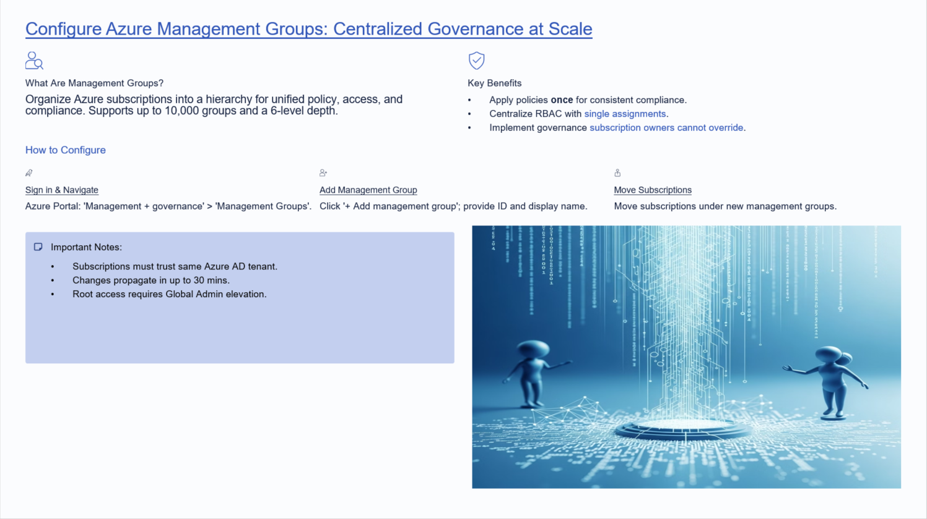

Azure RBAC:

Access management for cloud resources is a critical function for any organization that is using the cloud. Azure role-based access control (Azure RBAC) helps you manage who has access to Azure resources, what they can do with those resources, and what areas they have access to.
Azure RBAC is an authorization system built on Azure Resource Manager that provides fine-grained access management of Azure resources.

What can I do with Azure RBAC?
Here are some examples of what you can do with Azure RBAC:
- Allow one user to manage virtual machines in a subscription and another user to manage virtual networks
- Allow a DBA group to manage SQL databases in a subscription
- Allow a user to manage all resources in a resource group, such as virtual machines, websites, and subnets
- Allow an application to access all resources in a resource group

How Azure RBAC works
The way you control access to resources using Azure RBAC is to assign Azure roles. This is a key concept to understand – it's how permissions are enforced. A role assignment consists of three elements: security principal, role definition, and scope.

Security principal
A security principal is an object that represents a user, group, service principal, or managed identity that is requesting access to Azure resources. You can assign a role to any of these security principals.
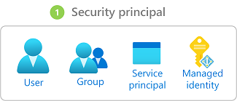

Role definition
A role definition is a collection of permissions. It's typically just called a role. A role definition lists the operations that can be performed, such as read, write, and delete. Roles can be high-level, like owner, or specific, like virtual machine reader.
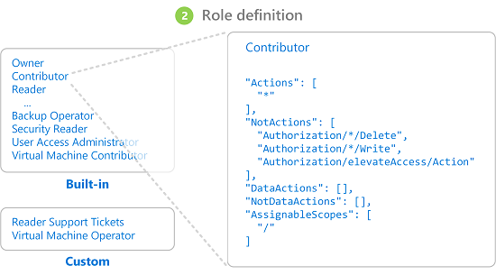
Azure includes several built-in roles that you can use. For example, the Virtual Machine Contributor role allows a user to create and manage virtual machines. If the built-in roles don't meet the specific needs of your organization, you can create your own Azure custom roles.

Scope
Scope is the set of resources that the access applies to. When you assign a role, you can further limit the actions allowed by defining a scope. This is helpful if you want to make someone a Website Contributor, but only for one resource group.
In Azure, you can specify a scope at four levels: management group, subscription, resource group, or resource. Scopes are structured in a parent-child relationship. You can assign roles at any of these levels of scope.
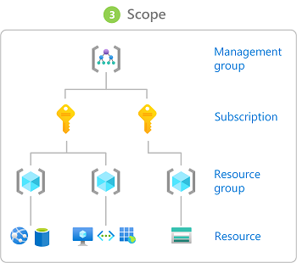
For more information about scope, see Understand scope.

Role assignments
A role assignment is the process of attaching a role definition to a user, group, service principal, or managed identity at a particular scope for the purpose of granting access. Access is granted by creating a role assignment, and access is revoked by removing a role assignment.
The following diagram shows an example of a role assignment. In this example, the Marketing group has been assigned the Contributor role for the pharma-sales resource group. This means that users in the Marketing group can create or manage any Azure resource in the pharma-sales resource group. Marketing users do not have access to resources outside the pharma-sales resource group, unless they are part of another role assignment.
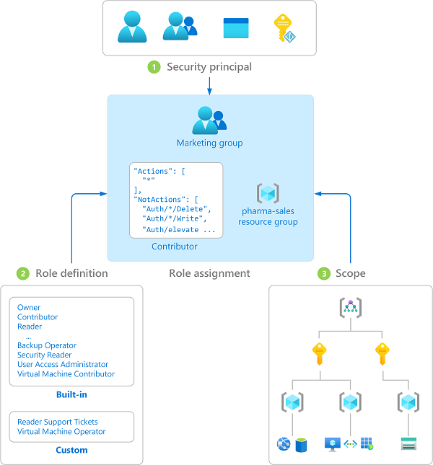
You can assign roles using the Azure portal, Azure CLI, Azure PowerShell, Azure SDKs, or REST APIs.
For more information, see Steps to assign an Azure role.

Groups
Role assignments are transitive for groups which means that if a user is a member of a group and that group is a member of another group that has a role assignment, the user will have the permissions in the role assignment.
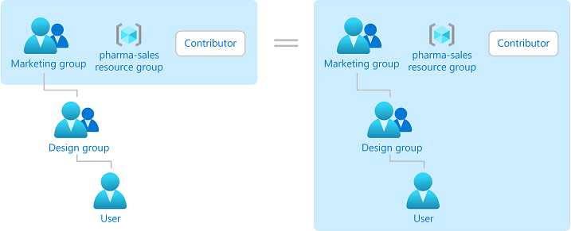

Multiple role assignments
So what happens if you have multiple overlapping role assignments? Azure RBAC is an additive model, so your effective permissions are the sum of your role assignments. Consider the following example where a user is granted the Contributor role at the subscription scope and the Reader role on a resource group. The sum of the Contributor permissions and the Reader permissions is effectively the Contributor role for the subscription. Therefore, in this case, the Reader role assignment has no impact.
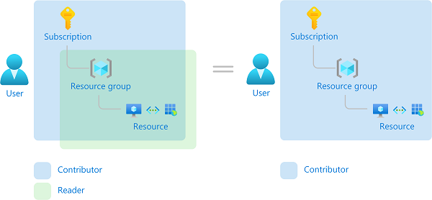

Deny assignments
Previously, Azure RBAC was an allow-only model with no deny, but now Azure RBAC supports deny assignments in a limited way. Similar to a role assignment, a deny assignment attaches a set of deny actions to a user, group, service principal, or managed identity at a particular scope for the purpose of denying access. A role assignment defines a set of actions that are allowed, while a deny assignment defines a set of actions that are not allowed. In other words, deny assignments block users from performing specified actions even if a role assignment grants them access. Deny assignments take precedence over role assignments.
For more information, see Understand Azure deny assignments.

How Azure RBAC determines if a user has access to a resource
The following are the high-level steps that Azure RBAC uses to determine if you have access to a resource. These steps apply to Azure Resource Manager or data plane services integrated with Azure RBAC. This is helpful to understand if you are trying to troubleshoot an access issue.
- A user (or service principal) acquires a token for Azure Resource Manager.
The token includes the user's group memberships (including transitive group memberships).
- The user makes a REST API call to Azure Resource Manager with the token attached.
- Azure Resource Manager retrieves all the role assignments and deny assignments that apply to the resource upon which the action is being taken.
- If a deny assignment applies, access is blocked. Otherwise, evaluation continues.
- Azure Resource Manager narrows the role assignments that apply to this user or their group and determines what roles the user has for this resource.
- Azure Resource Manager determines if the action in the API call is included in the roles the user has for this resource. If the roles include Actions that have a wildcard (*), the effective permissions are computed by subtracting the NotActions from the allowed Actions. Similarly, the same subtraction is done for any data actions.
Actions - NotActions = Effective management permissions
DataActions - NotDataActions = Effective data permissions
- If the user doesn't have a role with the action at the requested scope, access is not allowed. Otherwise, any conditions are evaluated.
- If the role assignment includes conditions, they are evaluated. Otherwise access is allowed.
- If conditions are met, access is allowed. Otherwise access is not allowed.
The following diagram is a summary of the evaluation logic.
